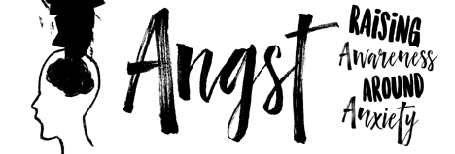

IndieFlix Shines the Light on Anxiety with Must-See Documentary,
“ANGST: RAISING AWARENESS AROUND ANXIETY”

NEW FILM CREATED TO START COMMUNITY CONVERSATIONS ABOUT ANXIETY &
PROVIDE TOOLS, RESOURCES & HOPE SCREENS ON
THURSDAY, March 8 @ 6:30 in the Timpanogos H.S. Auditorium
All THS Parents and Students are invited to this free event.

IndieFlix, along with its non-profit arm, the IndieFlix Foundation, is sparking a global conversation about anxiety through screenings of its brand-new documentary, “Angst: Raising Awareness Around Anxiety”. On March 8th, Timpanogos High School will hold a special screening of the documentary at 6:30 pm in the school auditorium. The event will feature a viewing of the 56-minute film, followed by a short panel discussion and information session.
On Monday March 12th, Timpanogos students will be viewing the same film and teachers will use guided processing questions to discuss the film.

Producers Scilla Andreen and Karin Gornick have one goal: to start a global conversation and raise awareness around anxiety. Through candid interviews, they utilize the power of film to tell the stories of many kids and teens who discuss their anxiety and its impacts on their lives and relationships, as well as how they’ve found solutions and hope. The film also includes a special interview with Michael Phelps, a mental health advocate and one of the greatest athletes of all-time. In addition, the documentary provides discussions with mental health experts about the causes of anxiety and its sociological effects, along with the help, resources and tools available to address the condition.

Anxiety disorders are the most common mental health challenge in the U.S., impacting 54 percent of females and 46 percent of males, with age seven being the median age of onset, according to the World Health Organization. While anxiety disorders are highly treatable, only one-third of those suffering receive treatment.

"The conversation surrounding mental health really hits home for me,” said Michael Phelps. “Many people don’t understand how debilitating mental illness truly can be, and even more than that, how common it is, yet people are afraid to have the serious discussions about it. I welcomed the opportunity to be a part of ‘Angst’ to further the dialogue around mental health and to help people understand the impact anxiety has on our mental state and encourage people, especially kids, to ask for help."

